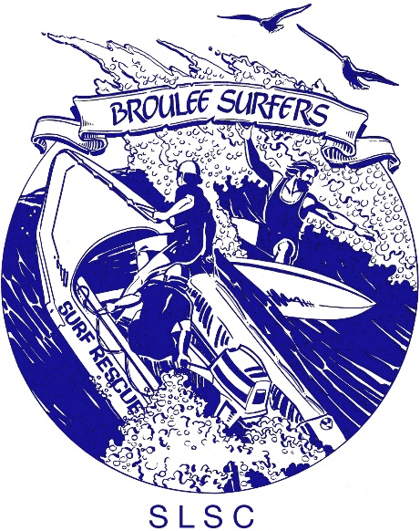

2023/24 BSSLSC Awards Nomination Form

Junior Achiever or Club Person of the Year
(PLEASE COMPLETE A SEPERATE FORM FOR EACH CATEGORY)

Please note: Only 2023/24 (01/07/2023– 30/04/2024) season is taken into consideration.

NOMINATIONS CLOSE AT BSSLSC 5 April 2024

Late entries will not be accepted

CATEGORY NAME:

NOMINEE NAME:

Member nominated must be a financial member in the year nominated. PLEASE ADD ADDITIONAL INFORMATION:

Name & signature of proposer Name & Signature of Club Seconder

Nominations to be emailed to brosslsc@bigpond.net.au by 5pm Friday 5 April

AWARD CRITERIA

CLUB PERSON OF THE YEAR
This award recognises an individual who has demonstrated a high level of commitment and achievements in a range of different areas in the Club throughout the year, or who has shown significant and outstanding achievements in a specific area. The individual’s contribution demonstrably enhances the development of Surf Life Saving. They may be a volunteer in any area of Surf Life Saving.

Essential Criteria
- Current financial member of Surf Life Saving Australia
- Surf Life Saving Australia awards or certificates held (where applicable)
- Suitable role model and representative of the Club

Selection Criteria
Please include any additional supporting information with the nomination form.

JUNIOR ACHIEVER OF THE YEAR
This award recognises patrolling members, aged under 19 who have made an outstanding contribution to the delivery and development of Surf Life Saving activities in their first years of Surf Life Saving.

Essential Criteria
- Current financial member of Surf Life Saving Australia
- Must be under 19 years old
- Must be a patrolling member (Bronze Medallion or SRC holder) and made a solid contribution to the club
- Must be a positive role model and ambassador for the Surf Life Saving movement

Selection Criteria
Please include any additional supporting information with the nomination form

